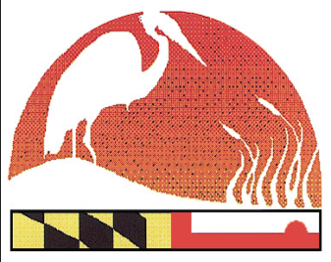
2021 Virtual Maryland Envirothon
The Maryland Envirothon

12407 Naves Cross Road NE
Cumberland, Maryland 21502
(240)-609-3508
chartsock@atlanticbbn.net

www.mdenvirothon.org
Rules, Regulations and Guidelines

- Students in grades 9-12 are eligible to compete. Student teams may be formed from a high school, 4-H club, FFA club, or any other sanctioned local, regional, state, or nationally recognized school or club that sponsors youth in grades 9-12.

2. All registration forms must be typed or neatly printed in order to assure the Maryland Envirothon Steering Committee has received legible, accurate information. All forms are available in electronic format.

3. Each team will consist of no more than five members. Teams may compete with less than five members; however, a team with less than five members will not be allowed to advance to the NCF National Envirothon should they win the Maryland Envirothon.

4. Multiple teams from each county high school or sanctioned club may participate in the 2021 Virtual Maryland Envirothon.

5 Advisors, coaches, parents or any others are not allowed to assist students in any way during the exams. Teams will be on the honor system.

6. Teams will be able to log-on and complete each exam between the hours of 9AM – 9PM. Once the team begins the exam, they will have 120 minutes to complete the exam.

7. The team captain as designated on the Team Participation Form, will submit one completed exam from that team.

8. During the exams, teams are to only have access to and utilize those resource materials as specified by the resource professionals for that specific discipline.

9. The Maryland Envirothon Committee requires a completed and signed Model Release form from ALL students participating in the 2021 virtual Maryland Envirothon, as students may be on video during the training and/or competition due to the virtual platform being used.

10. Students will be competing for the following awards;

1st Place - $500 Cash Scholarship to each team member
Framed Wildlife Print

1 of 2
2nd Place - $300 Cash Scholarship to each team member
Framed Wildlife Print

3rd Place - $200 Cash Scholarship to each team member
Framed Wildlife Print

4th Place – Wildlife Sculpture

5th Place – Wildlife Sculpture

Prizes will also be awarded to the team with the highest score in each resource area.

11. All students and advisors participating in the Maryland Envirothon will receive a Maryland Envirothon T-Shirt.

12. Winners will be announced at a virtual awards ceremony to be held Thursday, May 6, 2021 at 7:00 PM.

13. Rules and regulations of the Maryland Envirothon are subject to change. Any and all changes will be explained in advance to all teams and advisors.

14. It is the policy of the Maryland Envirothon to provide equal opportunity to all persons regardless of color, national origin, citizenship, status, physical or mental disability, race, religion, creed, gender, sex, sexual orientation, gender identity and/or expression, status with regard to public assistance, or any other characteristic protected by federal, state, or local law.

2 of 2

