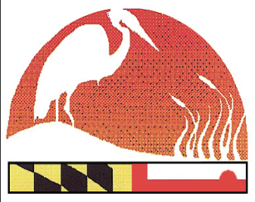
2021 Maryland Envirothon Model Release Form
www.mdenvirothon.org
The Maryland Envirothon

12407 Naves Cross Road NE
Cumberland, Maryland 21502
(240)-609-3508
chartsock@atlanticbbn.net

I hereby grant the right to photograph and/or video my dependent and use photographs and/or other digital reproductions of him/her or other reproduction of his/her physical likeness for publication processes, whether electronic, print, digital or electronic publishing via the Internet to the Maryland Envirothon and to its employees, agents, assigns, and sponsors (Maryland Association of Soil Conservation Districts, Maryland Department of Agriculture, Maryland Department of Natural Resources, Maryland Department of the Environment, and US Department of Agriculture)

Model's Signature: _______________________________________________________________

Model's Printed Name: ____________________________________________________________

Address: _______________________________________________________________________

Date: __________________________________________________________________________

                 

I certify that I am a custodial parent and have the aforementioned rights to assign.

Signature of Parent / Guardian: _____________________________________________________
(for persons under 18 years of age)

I certify that I am 18 years of age or older: ____________________________________________

Signature of Participant: ___________________________________________________________

Printed Name: ___________________________________________________________________

Address: ________________________________________________________________________

Date: ___________________________________________________________________________

                 

