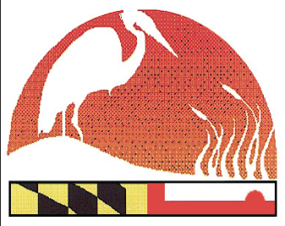
April 7, 2017
EXECUTIVE BOARD
Barry Burch
Chair
MASCD/Member at Large

Craig Zinter
Vice Chair
Talbot SCD

Mike McGinnis
Treasurer/Ex Officio
MASCD

Ginger Noble
Secretary
Washington SCD

Tom Koviak
MDA

Jenny Lee
MDA

Stacy Epperson
MD-DNR

Adrienne Diaczok
MDE

Max Tucker
MDE

Jim Brewer
NRCS

Dean Cowherd
NRCS

MD ENVIROTHON COORDINATOR
Craig Hartsock

STEERING COMMITTEE
Terrie Shank
MAEF

Adam Heavner
Allegany SCD

Larry Fykes
Somerset SCD

Kerry Wixted
MD-DNR

Karen Houtman
Dorchester SCD

Kristal McCormick
Howard SCD

Karen Miller
Kent SWCD

David Pluumer
Montgomery SCD

Earl “Bud” Reaves
Member at Large

Debbie Sandlin
Prince George’s SCD

Linda Subda
MASCD
Member at Large

Bruce Young
St. Mary’s SCD

The Maryland Envirothon
Allegany Soil Conservation District
12407 Naves Cross Road NE
Cumberland, Maryland 21502
(301)-777-1494, Ext. 117
chartsock@atlanticbbn.net
www.mdenvirothon.org

To: Advisors of the Envirothon Winning Team

From: Barry Burch, Maryland Envirothon Chairman
Craig Zinter, Maryland Envirothon Vice-Chairman

We would like to congratulate you and your team for winning your local county Envirothon competition!
The 27th Maryland Envirothon competition will take place Thursday, June 15th through Friday, June 16th at Camp Pecometh, located at 136 Bookers Wharf Road, Centreville, MD 21617.
Enclosed you will find a tentative agenda and registration documents. Registration will take place on Thursday, June 15th between 11:00am and 12:00pm. In the registration packet, students are required to sign-up for three (3) training activities they wish to attend on Training Day. The team will have to determine how they will cover all of the training areas as they will not individually be able to cover all 5 areas of discipline. Please note it is required that the Training Form be returned with the registration forms.

Please note that your team will need to bring pillows, bed linens, blankets and towels and toiletries as they are not provided by the camp.

On Thursday June 15th, immediately following registration, teams will attend training activities from 12:45pm. until 4:50pm. The evening, after dinner, is devoted to nighttime educational activities.

The 2017 Maryland Envirothon testing portion will take place on Friday, June 16 from 8:00am to 12:00 pm. Students will travel from one resource area to another, completing each exam within a 40 minute time frame. The winning team will be the one that has the highest cumulative score for the five areas of discipline. The competition will be followed by the awards ceremony. In July, the winning team will travel to Mount St. Mary’s University, Maryland to represent Maryland at the 2017 National Envirothon.

Enclosure

