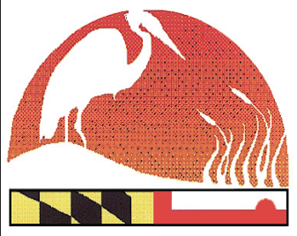
2017 Maryland Envirothon Team Participation Form
www.mdenvirothon.org
The Maryland Envirothon
Allegany Soil Conservation District
12407 Naves Cross Road NE
Cumberland, Maryland 21502
(301)-777-1494, Ext. 117

PLEASE TYPE
(All information is REQUIRED)

County: _____________________ School (entire name): ______________________
Team Name: __________________________________________________________
Address: _____________________________ City/State/Zip: ___________________
Phone: ________________________________
Team Coach(es) at County Level: ________________________

NOTE: Appropriate gender chaperones must be present for mixed teams or prior district arrangements are to be made with another county. A district employee can serve as an advisor. One representative from a sponsoring organization must accompany team and be on-site at all times. (See “Maryland Envirothon Rules and Regulations”)

Name, County affiliation, and Cell # of person willing to co-chaperone your students.
*Note: Advisors/Chaperone (Names & Cell phone numbers are REQUIRED):

Male | Female
Name: ________________________________ | Name: ________________________________
County: _______________________________ | County: _______________________________
Cell: ________________________________ | Cell: ________________________________
Email Address: _________________________ | Email Address: _________________________

Number & type of special dietary requirements (i.e. vegetarian, vegan, gluten free, etc.): ______________ (Needed for food service contract)

MARK GENDER AND T-SHIRT SIZE NEXT TO STUDENT’S NAME.
Students:
- M or F size__

- M or F size__

- M or F size__

- M or F size__

- M or F size__

Advisors/Chaperone (Names & Cell phone numbers are REQUIRED):

- M or F size__

- M or F size__

