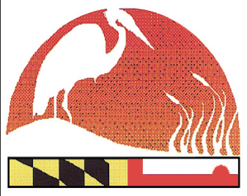
Registration Packet for County Coordinators
EXECUTIVE BOARD
Barry Burch
Chair
MASCD/Member at Large

Craig Zinter
Vice Chair
Talbot SCD

Mike McGinnis
Treasurer/Ex Officio
MASCD

Ginger Noble
Secretary
Washington SCD

Tom Koviak
MDA

Jenny Lee
MDA

Stacy Epperson
MD-DNR

Adrienne Diaczok
MDE

Max Tucker
MDE

Jim Brewer
NRCS

Dean Cowherd
NRCS

MD ENVIROTHON COORDINATOR
Craig Hartsock

STEERING COMMITTEE
Terrie Shank
MAEF

Adam Heavner
Allegany SCD

Larry Fykes
Somerset SCD

Kerry Wixted
MD-DNR

Karen Houtman
Dorchester SCD

Kristal McCormick
Howard SCD

Karen Miller
Kent SWCD

David Pluumer
Montgomery SCD

Earl “Bud” Reaves
Member at Large

Debbie Sandlin
Prince George’s SCD

Linda Subda
MASCD
Member at Large

Bruce Young
St. Mary’s SCD

The Maryland Envirothon
Allegany Soil Conservation District
12407 Naves Cross Road NE
Cumberland, Maryland 21502
(301)-777-1494, Ext. 117
chartsock@atlanticbbn.net
www.mdenvirothon.org

______ 1 – Registration Packet Checklist
______ 1 - Winning Team Letter
______ 1 - Maryland Envirothon Rules & Regulations, including Electronic Equipment Policy
______ 1 - Code of Conduct
______ 1 - Tentative Schedule
______ 1 - Medical Release form
______ 1 - Model release form
______ 1 - Student Letter of Intent
______ 1 - Advisor Letter of Intent
______ 1 - Student Survey
______ 1 - Team Participation Form
______ 1 - Team Training Sign-up Form
______ 1 – Pecometh Map
______ 1 - Arrival, registration, stay, and departure information w/ Items to Bring list
______ 1 - County Coordinator Questionnaire (return to MD Envirothon Coordinator by May 19, 2017)

Return the following required items (*) to MD Envirothon Coordinator by: May 19, 2017
Failure to fully complete and return all required forms will result in team not being registered.

______ 5 - * Code of Conduct
______ 5 - *Letter to Parents w/Medical Release form
______ 7 - *Model release form
______ 5 - *Student Letter of Intent
______ 2 - *Advisor Letter of Intent
______ 5 - *Student Survey
______ 1 - *Team Participation Form
______ 1 - *Team Training and Presentation Sign-up Form

Return ALL materials to:
The Maryland Envirothon
c/o Craig Hartsock
12407 Naves Cross Road NE
Cumberland, Maryland 21502
(301)-777-1494, Ext. 117

