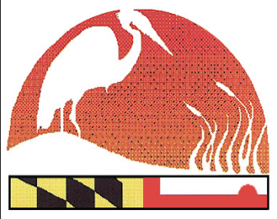
2017 Maryland Envirothon Questionnaire
www.mdenvirothon.org
The Maryland Envirothon
Allegany Soil Conservation District
12407 Naves Cross Road NE
Cumberland, Maryland 21502
(301)-777-1494, Ext. 117

Completed by: ______________________

The information provided will be used for program fundraising efforts and grant-writing narratives. Please try to completely answer all questions. Though, if you are unsure, leave the area blank. These questions are in reference to your 2016/2017 county program.

1. County/City/Winning High School/Team Name:

2. Total number of days spent training students for Envirothon:

3. Number of public & private high schools and home school organizations in county/city:

4. Number of participating public high schools:
private high schools:
home school organization:

5. Number of teams: _________ students: _________

6. Number of: repeat students: _________ repeat advisors: _________

7. Number of volunteers assisting your county Envirothon program:

8. Name of state/federal agencies that assist:

9. Total number of teachers participating:

10. Actual numbers of ethnic diversity of your participants:
a. Hispanic: c. African-American: e. Asian:
b. Native American: d. Anglo: f. Other:
Total Number of your participants _______________

11. Number of minority students from winning team:

12. From the winning team: # male students: _________ b. # female students: _________

13. Are there any challenges for taking on more teams in 2017-2018?

14. Do you have enough resource trainers?

15. Will your county have a 2017/2018 Envirothon program?

