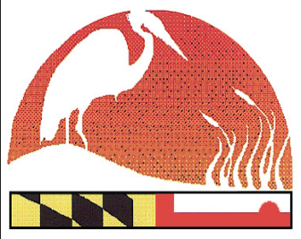
2017 Maryland Envirothon Advisor Letter of Intent
www.mdenvirothon.org
The Maryland Envirothon
Allegany Soil Conservation District
12407 Naves Cross Road NE
Cumberland, Maryland 21502
(301)-777-1494, Ext. 117

By signing below, I certify that I understand that the Maryland Envirothon is part of a progressive competition. If the participant is an advisor to that team, he/she will be expected to participate as Maryland’s representative at the 2017 North American Envirothon to be held July 23 - 29 in Emmitsburg, Maryland at Mount St. Mary’s University.

I understand that the MD Envirothon Committee will cover basic participation costs (i.e.: travel, lodging, meals, excluding passports). All additional costs (i.e.: personal purchases, souvenirs, etc.) will be at my personal expense.

Signature of Advisor:__________________________________________________________
Date

