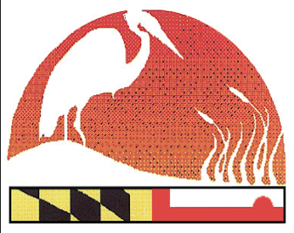
2017 Maryland Envirothon Model Release Form
www.mdenvirothon.org
The Maryland Envirothon
Allegany Soil Conservation District
12407 Naves Cross Road NE
Cumberland, Maryland 21502
(301)-777-1494, Ext. 117

I hereby grant the right to photograph me and use photographs and/or other digital reproductions of me or other reproduction of my physical likeness for publication processes, whether electronic, print, digital or electronic publishing via the Internet to the Maryland Envirothon and to its employees, agents, assigns, and sponsors (Maryland Association of Soil Conservation Districts, Maryland Department of Agriculture, Maryland Department of Natural Resources, Maryland Department of the Environment, and US Department of Agriculture)

Model's Signature: _______________________________________________________________

Model's Printed Name: ____________________________________________________________

Address: _______________________________________________________________________

Date: __________________________________________________________________________

                 

