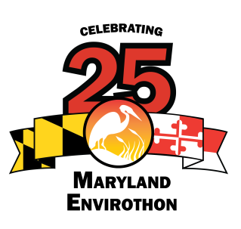

Allegany Soil Conservation District

12407 Naves Cross Road NE

Cumberland, Maryland 21502

(301)-777-1494, Ext. 117

Executive Board

**Barry Burch**

Chair  
MASCD/Member at Large

Craig **Zinter**

Vice Chair  
Talbot SCD

Mike McGinnis

Treasurer/Ex Officio  
MASCD

**Ginger Noble**

Secretary  
Washington SCD

**Tom Koviak**

MDA

**Jenny Lee**

MDA

**Stacy Epperson**

MD-DNR

**Adrienne Diaczok**

MDE

**Max Tucker**

MDE

Jim Brewer

NRCS

**Dean Cowherd**

NRCS

MD Envirothon Coordinator

Craig Hartsock  
12407 Naves Cross Road NE  
Cumberland, MD 21502  
(301) 777-1494, Ext. 117  
chartsock@atlanticbbn.net

Steering Committee

**Terrie Shank**

MAEF

**Larry Fykes**

Somerset SCD

Kerry Wixted

MD-DNR

**Karen Houtman**

Dorcheste­­r SCD

**Kristal McCormick**

Howard SCD

**Karen Miller**

Kent SWCD

David Plummer

Howard SCD

**Earl ‘Bud’ Reaves**

Member at large

**Debbie Sandlin**

Prince George’s SCD

**Linda Subda**

MASCD

Member at Large

**Bruce Young**

St. Mary’s SCD

Adam Heavner

Allegany SCD

www.mdenvirothon.org

**2017 Maryland Envirothon**

**Committee Members/Resource Personnel Registration**

Name:_______________________________________________________

Committee Member/Resource Area_______________________________

Phone #:_____________________________________________________

E-Mail:_______________________________________________________

Number of family members attending? Male___ Female___

Names of family members attending_______________________________

Number to pay for lodging and meals*_____________________________

**Please place X on all that apply**

___ I will be sleeping on site Wednesday night, June 14th

___ I will be sleeping on site Thursday night, June 15th

___ I will **not** be sleeping on site, do not reserve me a space

**Please place X all meals needed. Include family members in count.**

___ Thursday dinner ($9)

___ Friday breakfast ($7)

___ Friday awards lunch ($8)

**Are you a vegetarian?** Yes____ No____

Registration and checks are due by **Tuesday May 30, 2017**

**Send to: Craig Hartsock**

**Maryland Envirothon**

**12407 Naves Cross Road, NE**

**Cumberland, MD 21502**

**\*Note: Committee and Resource Personnel meals and lodging is covered.**

The Maryland Envirothon